Please join us as we Celebrate our

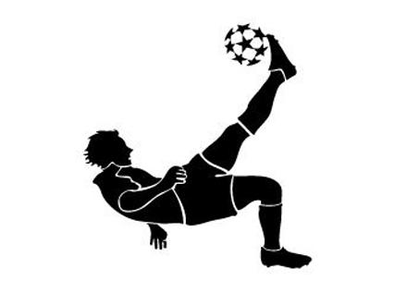
Victories in Athletics

Tuesday, May 15, 2012
2:45 pm to 3:45pm
MMS Cafeteria

Student Athletes only

All Athletes who attend will receive a
participation certificate, a sports ribbon, a chance to win cool door prizes, and a chance to participate in fun activities


Photo Booth Balloon Monsoon


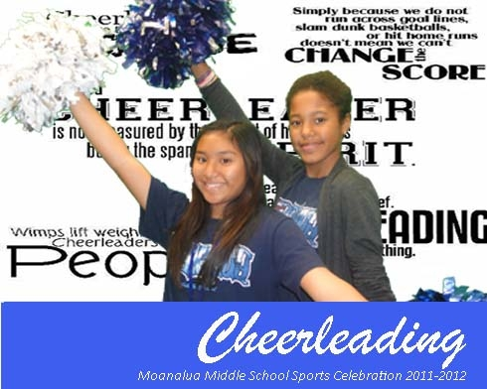

______________________________________________________________________________________
Please return to Mrs. Wong (P1) or to your Coach by Friday, May 10th


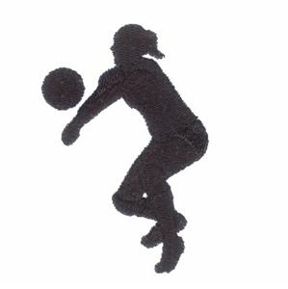
Athlete’s Name:___________________________________

Sport(s) Played:________________________________

_________________________________ _________________
Parent Signature Date

Students will need to find their own transportation home

Snack donations would be greatly appreciated

